Egyptian Mythology: Creation to Contendings
Syllabus/outline
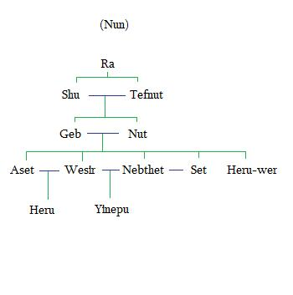
Important concepts
- Polyvalent logic
- Netjer
- Ma’at
- Isfet
- Nun
Major Characters
- Ra
- Wesir
- Set
- Aset
- Heru
Minor Characters
- Shu and Tefnut
- Geb and Nut
- Heru-wer
- Djehuty
- Khonsu
- Nebthet
- Yinepu
- Nit
- Hethert
- Sehkmet

